TUCKSHOP TALES  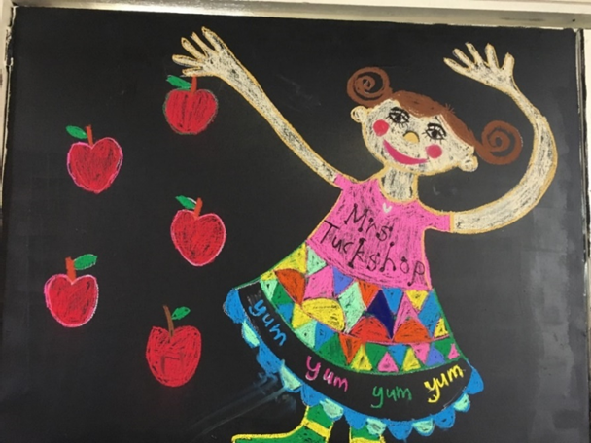  Hi everyone!  Changes to the Junior School Menu for Term 4 2021  Chicken Pesto Pasta – nut free (Halal)  $4.00  Wednesday Only  Crumbed Chicken Burger  with cheese, lettuce, tomato and mayo  $5.00  We desperately need volunteers  If you have some spare time, please contact  Dorisca and find out how you can help.  This is a KGSC P&C Association operated business.  Thanks for your support! | Term 4 2021  Reminders  Ensure you select the Junior School menu when ordering on the Qkr! App and online orders close each morning at 8.30am.  Paper bag orders are accepted until 9am.  Menu & how to order:  https://www.kgscpac.org/jnr-snr-tuckshop  BIRTHDAY TREATS  Order ice blocks or ice cream cups & we’ll deliver to the classroom  Can you help?  We love having volunteers! It helps keep our menu prices low. Flexible time slots, full training and morning tea provided. If you are able to help contact Dorisca.  contact  Tuckshop Convenor by dropping by or email kgscjuniortuckshop@gmail.com  Or phone 3552 7469

